**Evangeline Mapstone**

**05/04/2024**



**Data Visualisation Through Excel and Tableau**

**Table of Contents**

**Data Protection Policies and Procedures1**

**Excel task- Wealth of Nations data- GDP worksheet 2**

Workbook is protected and Column C data is displayed in British pound sign…………….…2a)

Data in GDP worksheet has been formatted into a table…………………………………………….2b)

Table has been filtered to only display information from 2019…………………………………….2c)

**GDP Chart……………………………………………………………………………………………………………3**

Chart has been created to display Rank, Country and GDP per Capita………………………….3a)

Title of chart has been added…………………………………………………………………………………3b)

Y Axis and X Axis have been added to chart………………………………………………………………3c)

Formatting applied to the chart to make it more visually appealing………………...……………3d)

**Top 20 Countries…………………………………………………………………………………………………….4**

Table sorted to display the top 20 highest ranking countries (GDP per Capita)………………..4a)

Bar chart added underneath table to display top 20 countries…………………………………… 4b)

**Tableau Visualisation…………………………………………………………………………………………… 5**

Data imported into Tableau and relationships set………………………………………………………5a)

Data types are checked and corrected…………………………………………………………………….5b)

**The Tableau charts…………………………………………………………………………………………………6**

Tableau charts edited to suit a client who is colourblind…………………………………..…………6a)

Final Dashboard is made………………………………………………..……………………………………..6b)

**Reflective…………………………………………………………………………………………………………….7**

**Data Protection Policies and Procedures**

When working with Data it is important to adhere to the Data Protection policies and procedures. Some of the general guidelines for this are as follows:

1. Data must be used fairly, lawfully and transparently, if using personal data, the purpose of using the data must be explained so that clear and transparent consent is obtained.
2. All Data must be used for explicit and specific purposes, you must be clear and open about the way data is processed. Do not use the data for any other purpose which is not compatible with the original.
3. You must use data adequately, and in a way that is relevant, and limited to only what is necessary. Do not use or obtain excessive data, if using personal data, ensure that is obtained in an appropriate way that you would be happy to show to the individual.
4. It is important to ensure that all data is accurate and kept up to date where necessary. You can monitor the data by using quality control procedures to identify and correct any errors.
5. Data must be stored in a secure location and only accessible to authorised personnel. You can ensure the security of digital data through use of password protected devices, files or links. Any physical copies of data must be appropriately stored away out of unauthorised view or access.
6. Do not keep data for longer than is necessary, when processing data you need to consider the appropriate time length to obtain it. Any data that is no longer required must be disposed of responsibly.
7. When processing data always do so in line with the applicable legal requirements and regulations which are in line with The Data Protection Act 2018. Further information on these rules is available online at [Data protection: The Data Protection Act - GOV.UK (www.gov.uk)](https://www.gov.uk/data-protection).

As a Data Analyst, it is important to be aware of these rules in order to complete tasks in line with the polices correctly, ensuring that all data is handled responsibly and any private information is securely protected.

**Excel Task- Wealth of Nations data- GDP worksheet**

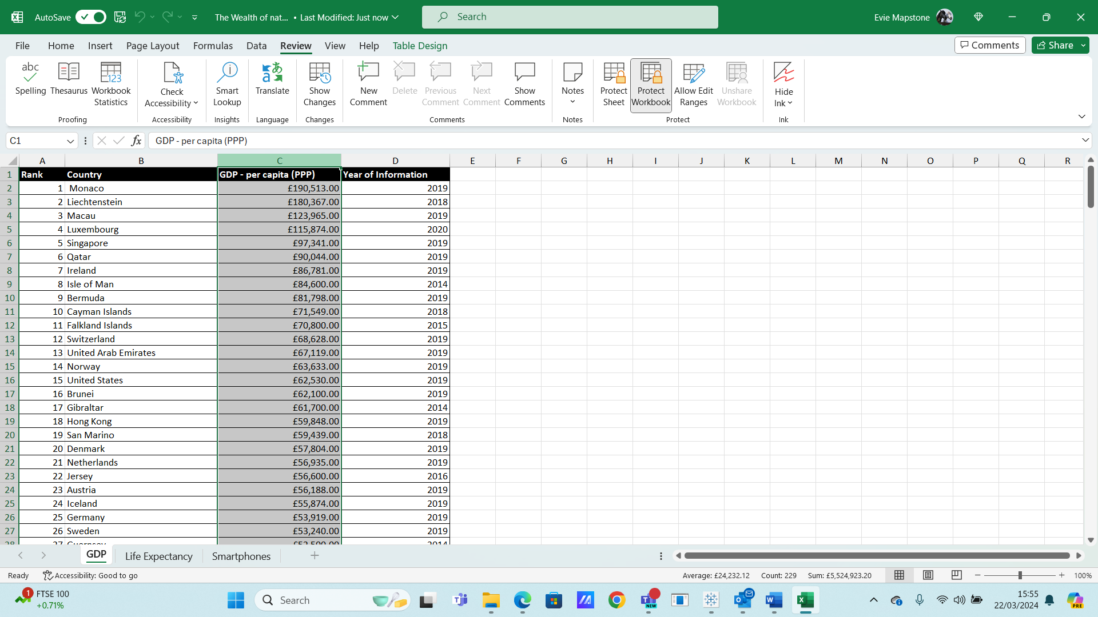Workbook is protected and Column C data is displayed in the British pound sign.

Data in GDP worksheet has been formatted into a table

Table has been filtered to only display information from 2019.

**GDP Chart**

Chart has been created to display the Rank, Country and GDP -per capita.

Title of chart added

X axis and Y axis both added.

Formatting applied to make the Chart more visually appealing.

Chart moved to a new Sheet tab and labelled with a suitable name.

**Top 20 highest ranking Countries**

Sorted table to display top 20 highest ranking countries.

Bar chart added underneath the Top 20 table, background colour added.

**Tableau Visualisation**

Data imported to Tableau and relationships set.

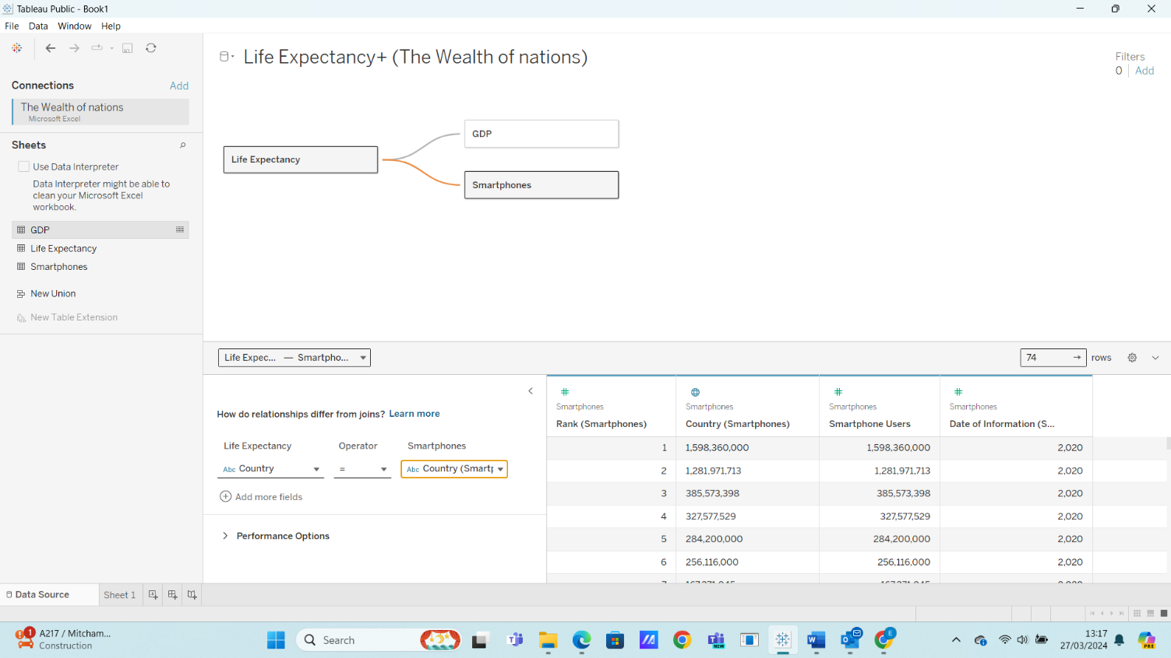

Check the data types, ensure they are set correctly.

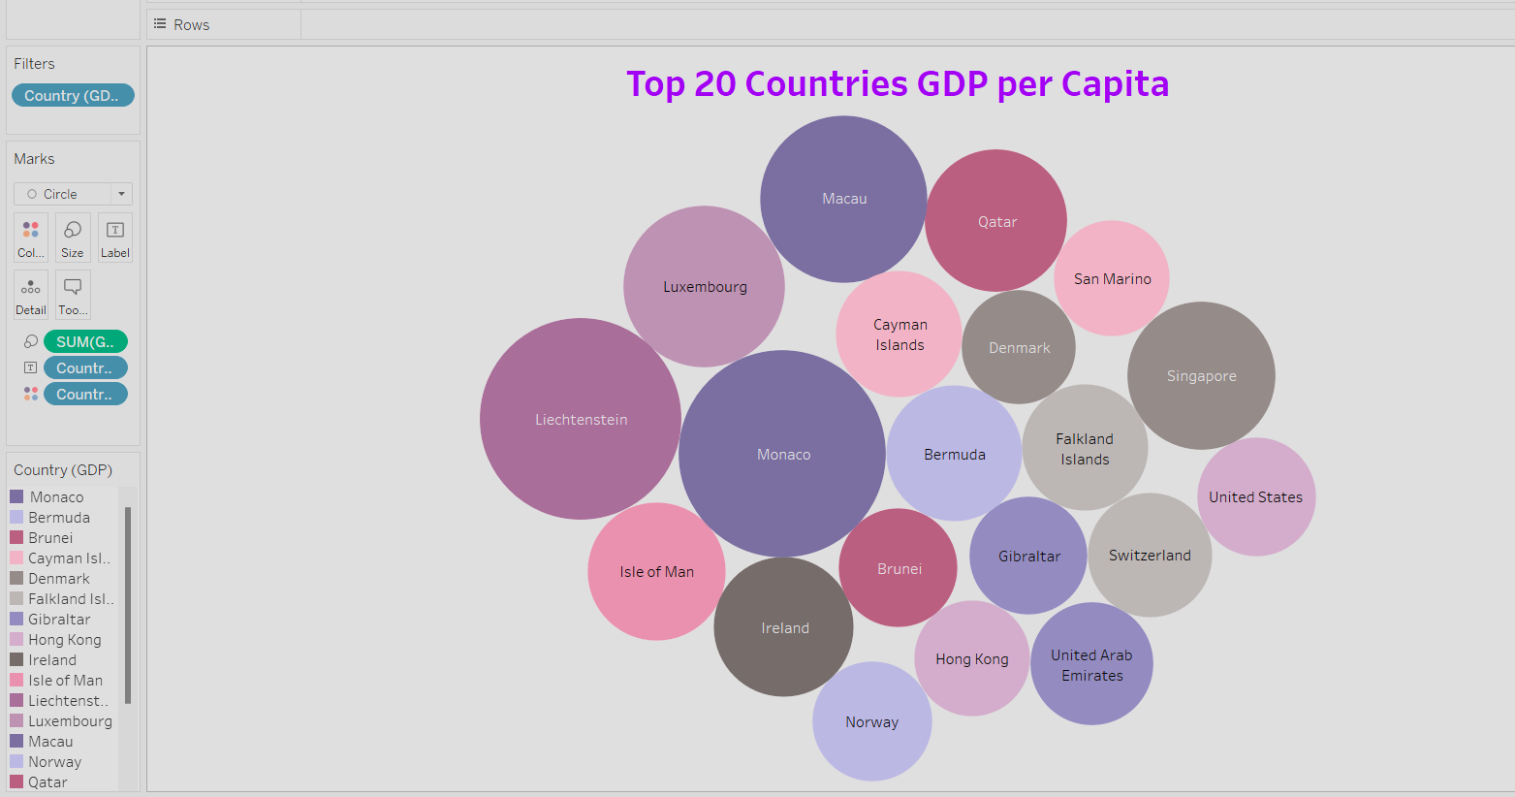**The Tableau charts**

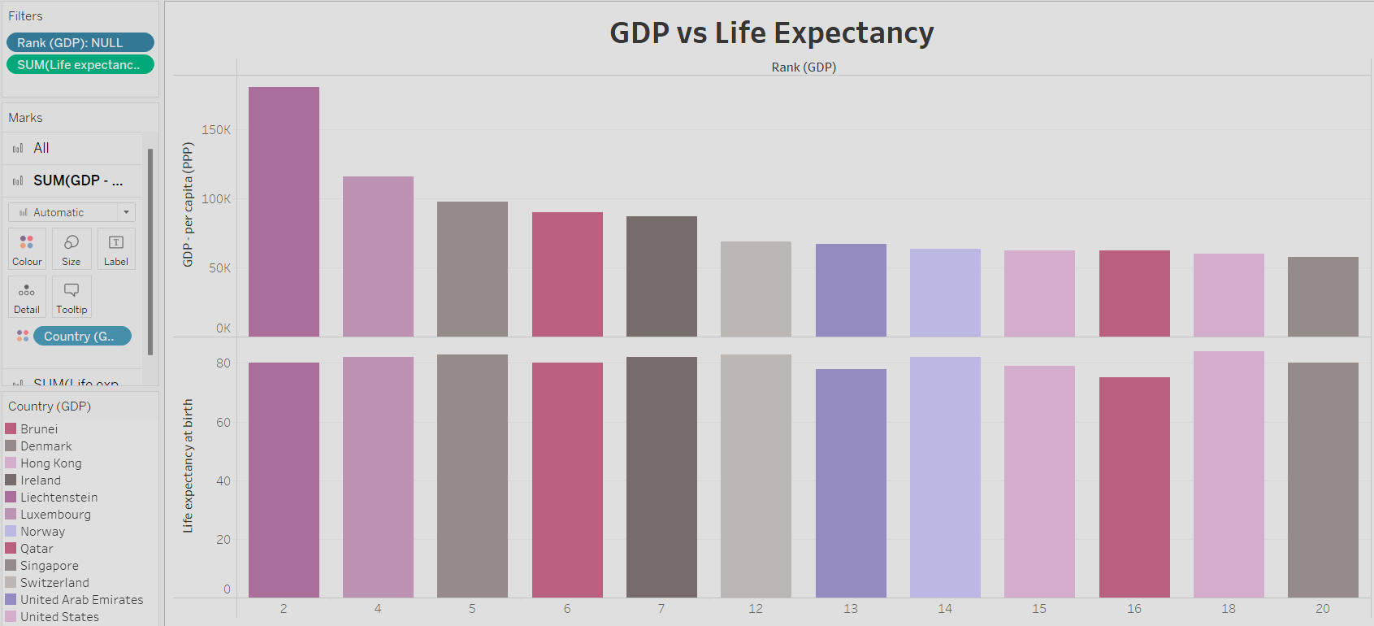

Tableau charts have been edited to suit a client who is colourblind

Final Dashboard made

Link to public dashboard:

[The Wealth of Nations | Tableau Public](https://public.tableau.com/app/profile/evie.mapstone/viz/TheWealthofNations_17116427611390/TheWealthofNationsDashboard?publish=yes)

**Reflection:**

The purpose of this assignment was to demonstrate what I have learnt about developing Data sets and visualisation using Excel and Tableau.

The first task of the assignment was to outline the data protection polices needed for processing data and state why they are important to remember as a data analyst. I researched online for this information; I had to careful about this as a lot of information online can be found as inaccurate, outdated or simply not relevant to this assignment. The most reliable source of information for this is the GOV.UK website, I included the link in this part of my assignment as reference.

The second task was Excel. Here I was to work on the data provided in the Wealth of Nations workbook; making edits to the GDP worksheet in particular.

I was familiar with using Excel previously so it has been interesting to learn more about the many other functions that can be used in this application, including using the protect workbook/protect worksheet tabs to limit anyone else making changes.

The instructions for this task were clear and I found this part of the assignment very straightforward overall, however I noticed that when I made the first chart displaying the data as Rank, Country and GDP per Capita that the Rank numbers would not show very clearly as there was not enough space on the chart to include this data. When I created a new table showing only the top 20 highest ranking countries only this resolved the issue.

The third task was working with Tableau. I had to import the data into Tableau , create four separate visuals and then finally a dashboard. I had not previously used Tableau so this has been a completely new skill to learn about on the Data Technician Bootcamp.

Overall this task went well, the challenging part was figuring out how to display the relationships between the data and determining which visuals were best used to display this information while keeping each visual looking unique and distinctive. I spent a bit more time on this part of the assignment, experimenting with different visuals until I could achieve the results that I wanted. I would like to learn more about how to create more varied visuals.